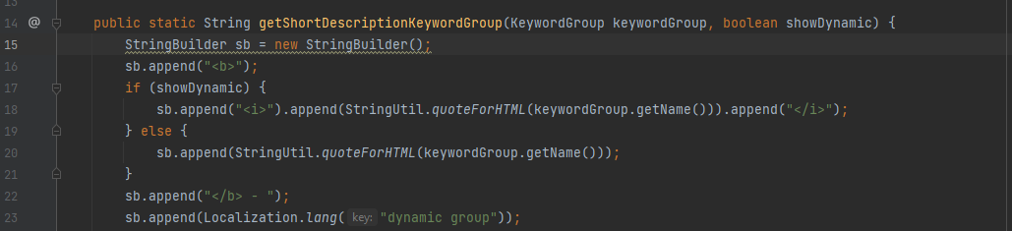
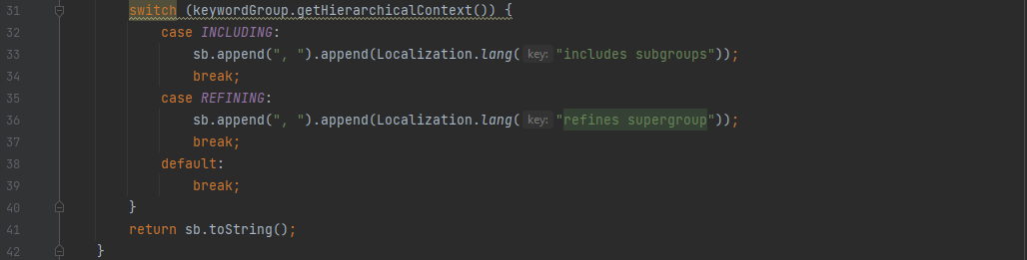
On the class GroupDescriptions.java, located on src\main\java\org.jabref\gui\groups, there are two occurrences of duplicated code. The second snippet appears two more times while the first snippet appears one more time.
This code can be refactored by creating two private methods one for each code snippet.

